RESUME

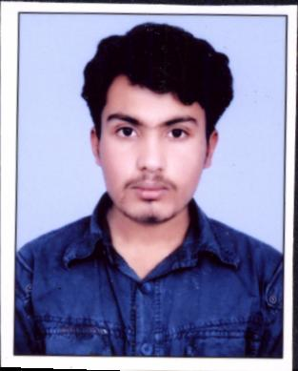
M.B.KISHORE
61-B, Sector-IV, D.I.Z Area
Baba Kharak Singh Marg,
New Delhi-110001
Contact No: +91-9910615684
e-mail: mbkishore99@gmail.com

OBJECTIVE

To give my career a solid start by joining an eminent company and contribute to the success of the company and thereby advancing my career.

EDUCATIONAL QUALIFICATION
S. No | Course/ Degree | Subjects | University/ Institute | Percentage
1. | 10th | Hindi, English, Mathematics, Science, Social science | C.B.S.E | 71.60
2. | +2 | Mathematics, physics, chemistry, English, computer science | C.B.S.E | 63.67
3. | B.Tech | Information Technology | Calicut University | 6.10 CGPA

SKILLS

Excellent Knowledge in MS-Office.
Event Management, Organizing Skills and Operations Management.
Extensive work experience in Govt. portals like e-office and pgportal.
Excellent Knowledge in Spreadsheets and making PowerPoint Presentations.

PROJECTS UNDERTAKEN

S. No
1. | MAIN PROJECT: “Stock Exchange System”
 | Front end: C#.NET
 | Back end: SQL
 | Project Details: This software provides buying and viewing of shares online.
2. | MINI PROJECT:“Privacy Preserving And Public Auditing For Data Storage Security In Cloud Computing”
 | Front end: Java
 | Back end: HBase (Linux)
 | Project Details: This software provides data storage security for contents stored in cloud.
3. | One of the Organizers for two Consecutive Civil Service Day which was conducted on 20-21 April 2017 and 20-21 April 2018

WORK EXPERIENCE
S. No | Organization/ Institute | Period from- to | Job Profile
1. | Virtuous Security & Facility Management Solutions Pvt. Ltd | 01.10.2016- Present | Back Office Operations and Event Management

OTHER ACHIEVEMENTS

- Letter of Appreciation given by Shri V.A.Chavda (Joint Secretary) from Department of Administrative Reforms & Public Grievances, regarding outstanding work on Civil Service Day, 2017

- An active participant in organizing cultural and technical fests in college.

HOBBIES

Travelling, Reading novels, Playing Badminton

LANGUAGES KNOWN

English, Hindi, Malayalam

PERSONAL DETAILS

Father’s Name: M.V.Balasubramanian
Mother’s Name: ParimalaBalasubramanian
Date of Birth: 14/12/1991
Present Address : 61-B,
Sector-4,
D.I.Z. Area,
Baba Kharak Singh Marg,
New Delhi- 110001
Mobile No: 9910615684
Nationality: Indian

